Human Resources Management System

Payroll Deduction and Allowance

Gross Salary = Basic Salary + Allowances + Overtime + Bonuses

Total Deductions = EPF + SOCSO + Tax + Loan + Unpaid Leave

Net Salary = Gross Salary - Total Deductions
Table | Purpose
payroll_cycles | Defines each payroll run (monthly/biweekly)
payroll_details | Stores computed salary details per employee
earnings | Tracks additional pay components
deductions | Tracks EPF, SOCSO, tax, unpaid leave, etc.
allowances | Defines fixed/variable allowance types

Leave Module
Leave Type | Description | Typical Rules
Annual Leave | Vacation days earned per year | Accrues monthly; can be carried forward
Medical Leave | Sick leave with doctor’s certificate | May require medical proof
Emergency Leave | Short-notice leave for emergencies | Usually limited days per year
Unpaid Leave | Deducted from salary | Auto-adjusted in payroll
Maternity / Paternity Leave | Based on labor laws | Fixed days per event
Study Leave | For training or courses | HR approval needed

Table | Purpose
employees | Master data for employees
leave_types | Defines types of leaves (annual, medical, unpaid, etc.)
leave_balances | Tracks how many leave days remain for each employee/type
leave_requests | Stores employee leave applications
leave_approvals | Stores manager/HR approval decisions

Additional  Idea | Description | Value
Chatbot Assistant | A chatbot inside the portal (powered by NLP) to help employees check leave balance or payslip summary. | Increases engagement
Payslip Explanation Mode | Hover or click each payslip item (e.g., EPF, SOCSO) to view how it’s calculated. | Improves transparency
Request Simulation Tool | Employee can “simulate” a leave request or salary change and see estimated impact before applying. | Helps decision-making

⚙️ Core Setup Components
- Leave Types: Define categories (Annual, Medical, Emergency, etc.) with units (Days/Hours) and colors for calendar.
- Leave Policies: Set rules (e.g. advance notice, medical proof required).
- Leave Entitlement: Set yearly quotas (e.g. 14 Annual, 10 Medical days). Support prorated and carry-over calculations.
- Earning Policy: Defines how employees accumulate leave (immediate, monthly, prorated).
- Approval Workflow: Configurable multi-level approvals based on role or department.
- Visibility Settings: Decide who can view whose leaves (self, department, branch, or organization-wide).
- Cancellation Rules: Employees can withdraw or request cancellation; HR can finalize.

📅 Leave Planning & Review
Managers can review leaves in three views:
- Planner: Calendar view
- Schedule: Table view (by department/branch)
- Review: List view (sorted by start date)
All linked with email notifications and approval controls.

Payroll Category

Term | Description | Party Responsible
Salary | The fixed, regular payment an employee receives as agreed in their employment contract, before any additions or deductions.[1][2][3] | Employer
Additions | Variable payments made on top of the basic salary.[2] This can include allowances (transport, housing), overtime pay, commissions, and bonuses.[2][4][5] | Employer
Gross Pay | The total earnings of an employee before any deductions are made. It is calculated by adding the basic salary and any other additions.[1][2][4][6] | Employer
Deductions | Total amount subtracted from the gross pay.[1][7] In Malaysia, deductions are either statutory (required by law) or non-statutory (requiring employee consent).[8] | Employee
Zakat | An obligatory religious tithe for eligible Muslims. This can be a voluntary payroll deduction to be paid to the relevant religious authorities.[9] | Employee
PCB (Potongan Cukai Bulanan) | Monthly Tax Deduction (MTD) is an income tax payment mechanism where employers deduct a portion of the employee's salary each month to be remitted to the Inland Revenue Board of Malaysia (LHDN).[10][11][12][13][14] | Employee
EPF (Employees Provident Fund) | Known as KWSP (Kumpulan Wang Simpanan Pekerja), this is a mandatory retirement savings fund.[15][16][17][18][19] | Both
 | Employee Contribution: A percentage of the employee's salary is deducted and contributed to their EPF account.[16]
 | Employer Contribution: The employer contributes an additional percentage of the employee's salary to the same EPF account.[16][20]
SOCSO (Social Security Organization) | Known as PERKESO (Pertubuhan Keselamatan Sosial), this scheme provides social security protection covering employment injuries, invalidity, and death.[21][22][23][24] | Both
 | Employee Contribution: A small percentage is deducted from the employee's salary.[21][23]
 | Employer Contribution: The employer contributes a larger percentage for the employee's coverage.[21][23]
EIS (Employment Insurance System) | Managed by PERKESO, this system provides temporary financial assistance and job search support to employees who have lost their jobs.[25][26][27][28][29] | Both
 | Employee Contribution: A fixed percentage (0.2%) is deducted from the employee's salary.[27][28]
 | Employer Contribution: The employer contributes a matching percentage (0.2%).[27][28]
NET Pay | Also known as "take-home pay," this is the final amount an employee receives after all statutory and other deductions have been subtracted from the gross pay.[1][2][30][31] | Employee
HRDF (Human Resources Development Fund) | Now officially known as HRD Corp, this is a levy imposed on employers to fund employee training and skills development. It is not deducted from the employee's salary.[32][33][34][35][36] | Employer

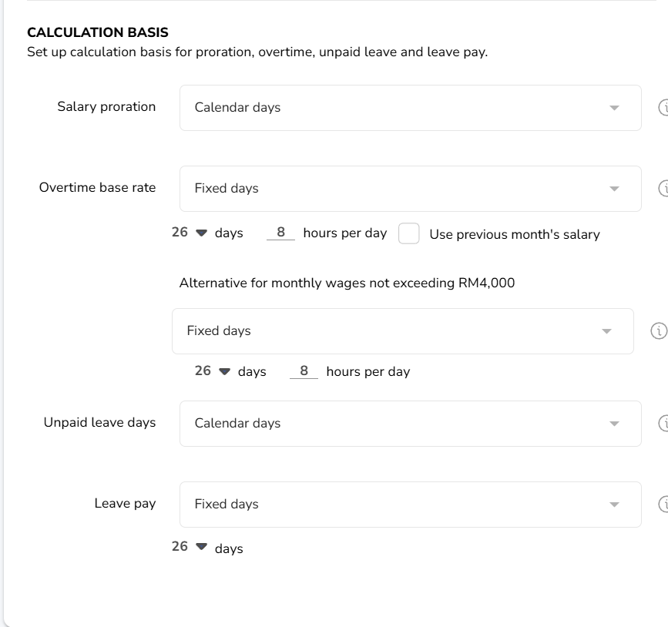

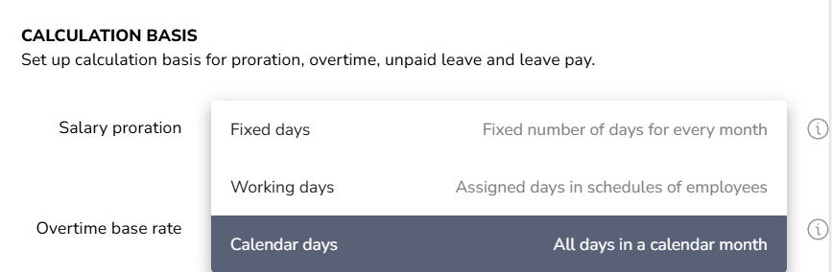
Compare between reviewed websites
Platform/Features | Payroll Panda | Leave Dates
Calendar | X (sync google/outlook)
Payroll report |  | X
Focus area | payroll | Leave management

Document needed
PERKESO
LHDN
KWSP/EPF- An employer shall register with the EPF within 7 days from the date the employer becomes liable to contribute, that is as soon as an employee is employed.
Registration I Akaun
Monthly contributions form A
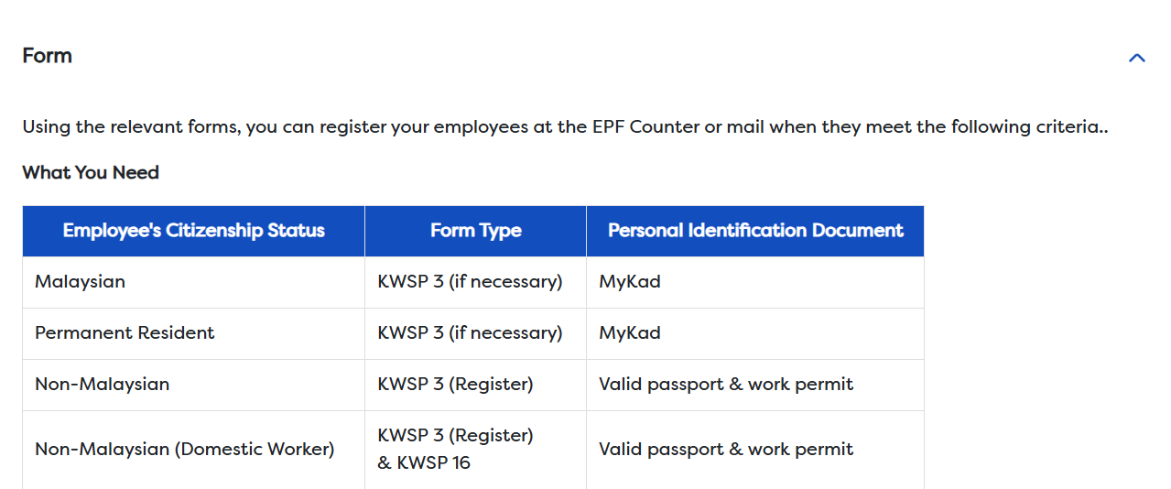

Deduction Type | Contribution Source | Rate / Formula
EPF | Employee | 11% of monthly wages
 | Employer | 13% (if monthly salary ≤ RM5,000) 12% (if monthly salary > RM5,000)
HRDF (Human Resource Development Fund) | Employer only | 1% of monthly wages
PCB (Monthly Tax Deduction) | Employee only | Variable (per LHDN schedule)
Unpaid Leave Deduction | Employee | (Basic Salary / 26) × No. of Leave Days
Zakat (optional) | Employee | Based on employee’s Zakat deduction setting

Gross Salary = Basic Salary + Allowances + Overtime + Other Additions (e.g., Bonuses, Commissions)
Total Employee Deductions = Employee EPF + Employee SOCSO + Employee EIS + PCB
Net Salary = (Basic Salary + Additions) - (Employee EPF + Employee SOCSO + Employee EIS + PCB)

Employee EPF Contribution:
Gross Salary x 11%

0-5000 | 0%
5001-20000 | 1%
20001-35000 | 3%
35001-50000 | 6%
50001-70000 | 11%
100001-400000 | 25%
400001-600000 | 26%
600001-2,000,000 | 28%
>2,000,000 | 30%

EIS Contribution Table
Both Contribution Rates are Calculated at ~0.2% of the Employee’s Salary

LEVY = [(BASIC SALARY - UNPAID LEAVE) + FIXED ALLOWANCE] x 1% (HRDF)

Calculation of Payroll

Unpaid Leave Deduction = Basic Salary/Working Days in Month * Number of Unpaid Days
Gross Salary = Basic Salary – Unpaid Leave Deduction + Allowances + Bonus + OT
EPF = Gross Salary * 0.11
SOCSO = Table 1
EIS = Table 2

HRDF > 10 Local Staff , must register, employer pay 1% of employee salary

LHDN – PCB Formula
- Estimated Annual Chargeable Income (TC)
Annual Salary = Monthly * 12
EPF 11% *12
SOCSO 24.75* 12
EIS 9.9*12
P = Personal Relief 9000 fixed
E = EPF Relief 4000 capped
S = SOSCO + EIS 350 capped

Total Relief = P + E + S
TC = Annual Salary – Total Relief
Apply Rule set by LDHN / 12

